## **Objectives**

* Define Props
* Explain Default Props
* Identify the differences between State and Props
* Explain reactDOM.render()

In this hands-on lab, you will learn how to:

* Use Props
* Apply reactDOM.render()

## **Prerequisites**

The following is required to complete this hands-on lab:

* Node.js
* NPM
* Visual Studio Code

## **Notes**

Estimated time to complete this lab: **60 minutes.**

Create a React Application named “shoppingapp” with a class component named “OnlineShopping” and “Cart”.

1. In Cart class, create 2 properties as mentioned below:

* Itemname
* Price

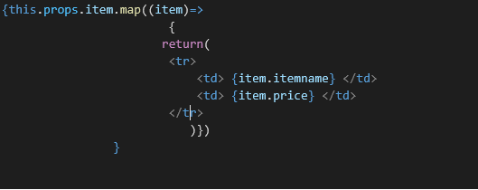

1. In OnlineShopping class, create an array of Cart and initialize 5 items.

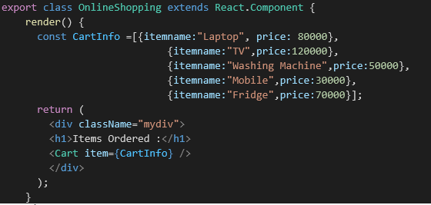

1. Loop through these items and display the data as shown below:

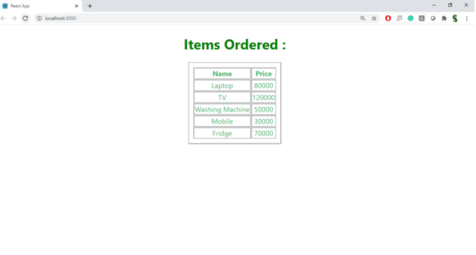

Cart.js

import React, { Component } from 'react';

class Cart extends Component {

  render() {

    return (

      <div style={{ border: '1px solid #ccc', padding: '10px', margin: '10px' }}>

        <h3>Item: {this.props.itemname}</h3>

        <p>Price: ₹{this.props.price}</p>

      </div>

    );

  }

}

Cart.defaultProps = {

  itemname: 'Unknown Item',

  price: 0

};

export default Cart;

OnlineShopping.js

import React, { Component } from 'react';

import Cart from './Cart';

class OnlineShopping extends Component {

  constructor(props) {

    super(props);

    this.state = {

      items: [

        { itemname: 'Laptop', price: 60000 },

        { itemname: 'Mobile Phone', price: 25000 },

        { itemname: 'Headphones', price: 3000 },

        { itemname: 'Smart Watch', price: 5000 },

        { itemname: 'Backpack', price: 1500 }

      ]

    };

  }

  render() {

    return (

      <div>

        <h1>Online Shopping Cart</h1>

        {this.state.items.map((item, index) => (

          <Cart key={index} itemname={item.itemname} price={item.price} />

        ))}

      </div>

    );

  }

}

export default OnlineShopping;

